Setting up a Google V3 API Service Account
In Nov 2014 google required the use of new V3, google API’s. These require more rigorous security than was previously the case.
This note describes how to set up a service account for google calendar (as an example). A service account allows credentials to be passed by an application (e.g. a plugin) without user interaction and is therefore suited to use by plugins.
I will describe a procedure that will later allow you to use the credentials with the Google Calendar 3 (GCal3) plugin.
- Go to the google developer console projects page here
https://console.developers.google.com/project
- Press the Create Project Button
Enter a project name – lets use ‘GCal3’
Press Create
Google will then take a few seconds to create the project
You should now be at a page that looks like this:

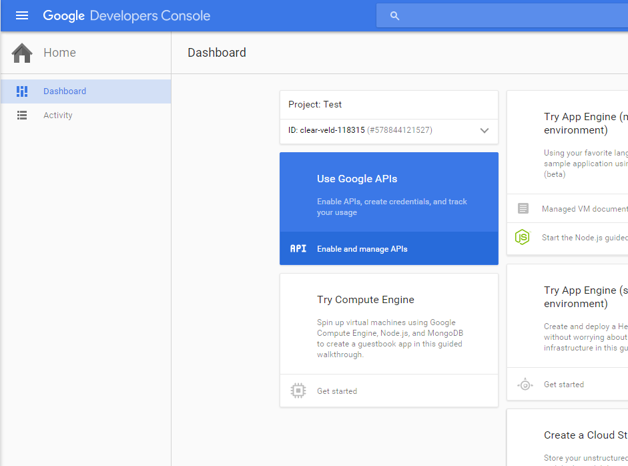

Click on Enable and manage APIs

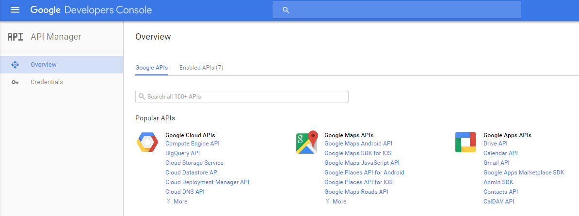
Click on Calendar API

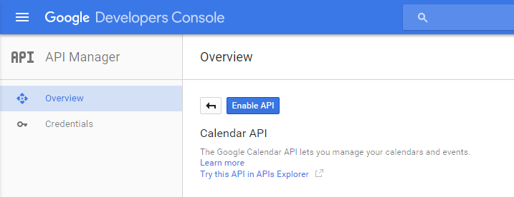

Click on Enable API

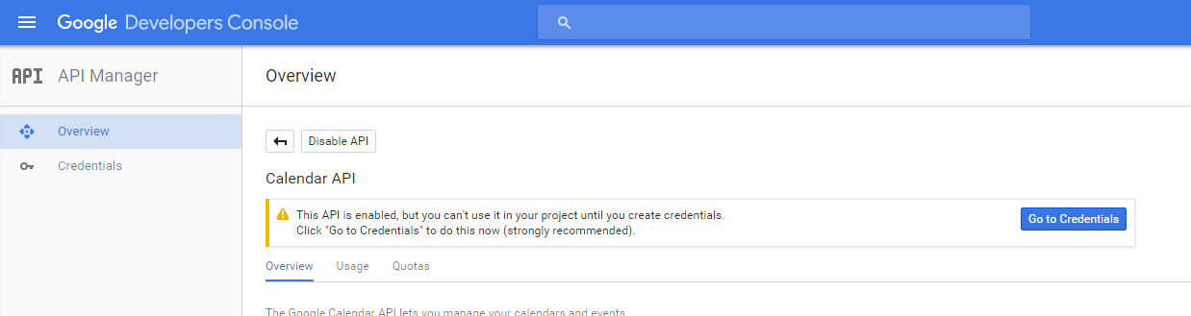

AT THIS POINT DO NOT click on Go to Credentials

Instead click on Credentials in the left hand column.

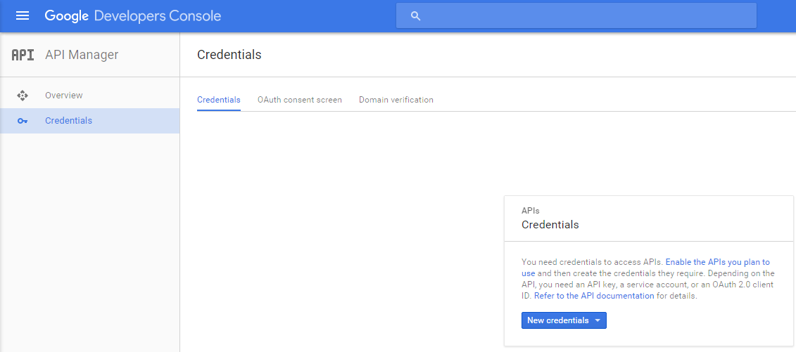

Click on New Credentials and select Service account key.

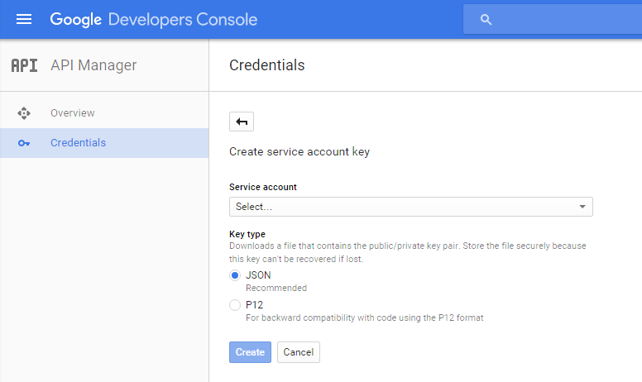

Click Select and it should change to New Service Account. There UI should now expand.

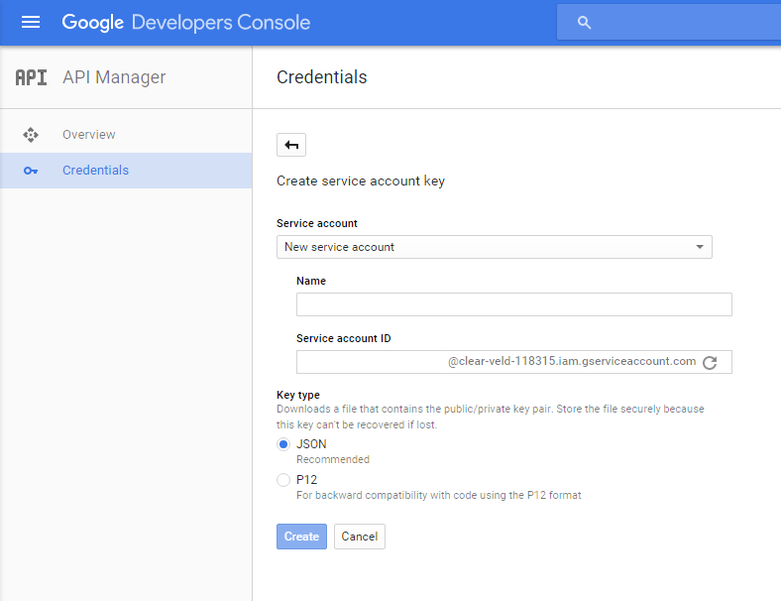

Enter a Name – lets use ‘g3plugin’

The Service account ID will auto-enter. Leave it the same.

Click Create.

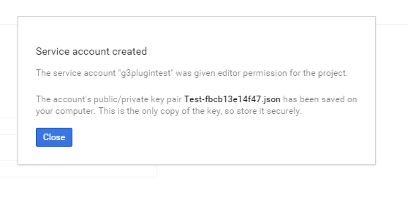

Click Close

Find the json file. It will have a name like GCal3-12ab34bblabla58.json (if you used the names suggested above). The file should be in the default download directory for your browser.

Copy this file to a suitable folder on your machine and rename it to GCal3.json
You have now created a google service account that will allow access to your calendar and you have downloaded the credentials that will be used by the GCal3 plugin.
BUT – you also need to:
- configure the calendar you want to access so that it knows which service accounts are allowed access, and
- Get the calendar ID
Open the json credentials file. It will look something like this
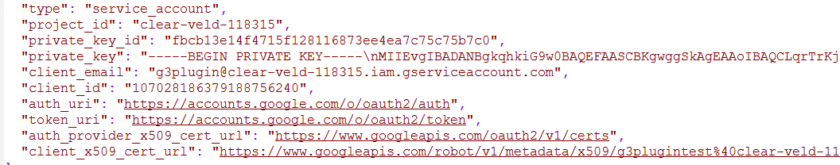

Copy the client_email value (the portion between the quotes) that looks like this

g3plugin@clear-veld-118315.iam.gserviceaccount.com

Be careful not to alter the json file !

Go to the google calendar that you want to access and do the following
Settings -* Calendars -* [your calendar] -*
Copy the Calendar ID. Everything in the box including <iframe to </iframe>. Save this as you will use it in the plugin to set the CalendarID

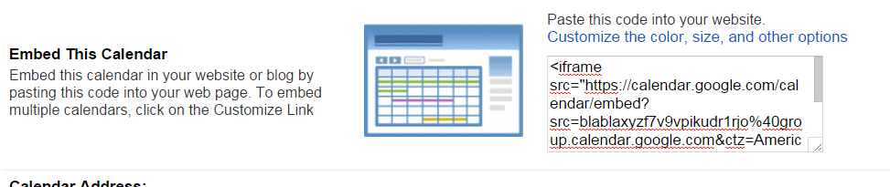

Next click on Share this Calendar
On the section that says “Share with specific people” Add the client-email from the step above. Change the permission to “Make Changes to Events”
Click on Add Person
You should now see the client_email listed like this

Click Save.

That’s it – go setup your plugin !

